Library management system
- Main Menu
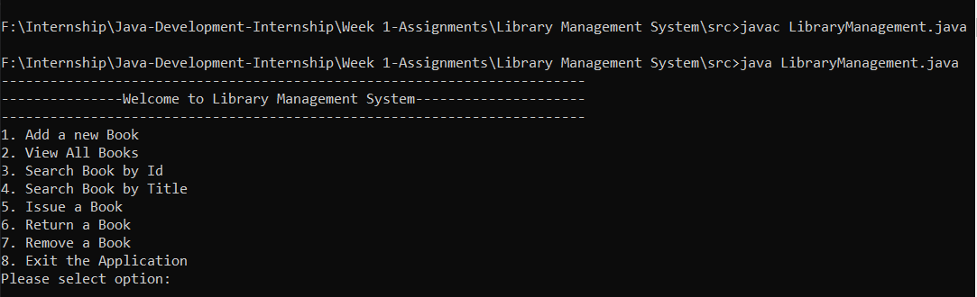
- Add book:
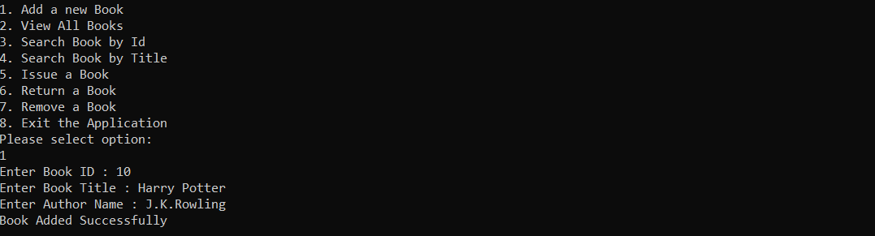
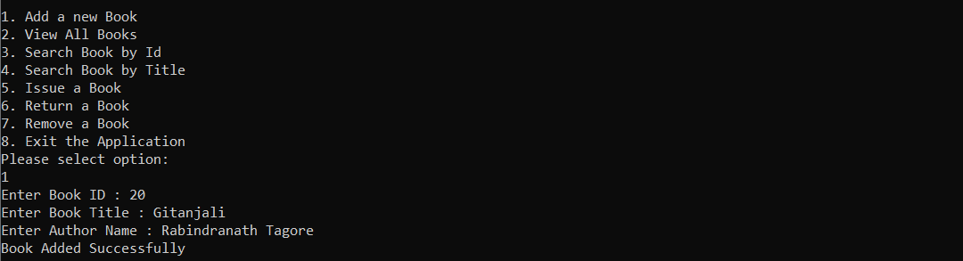
- View All Books:
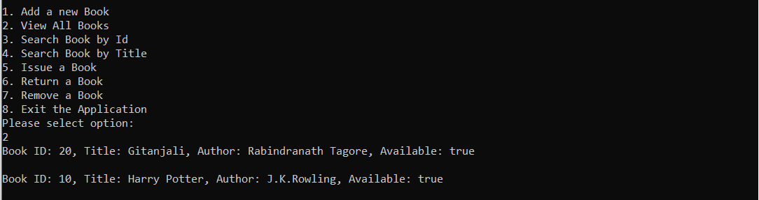
- Search Book By ID:
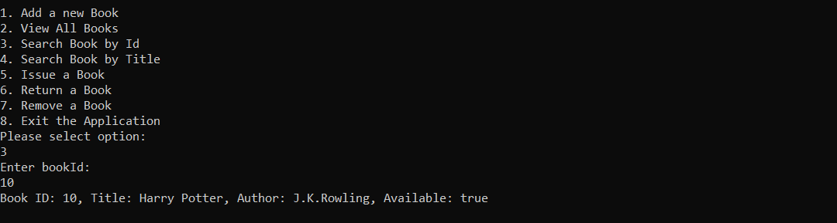
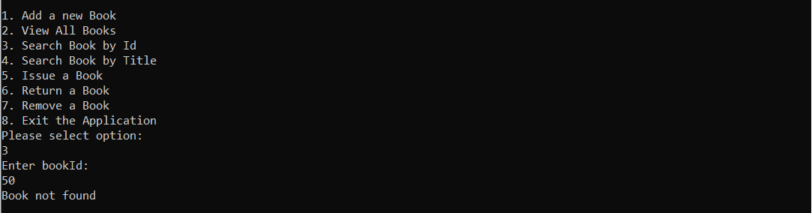
- Search Book By Title:
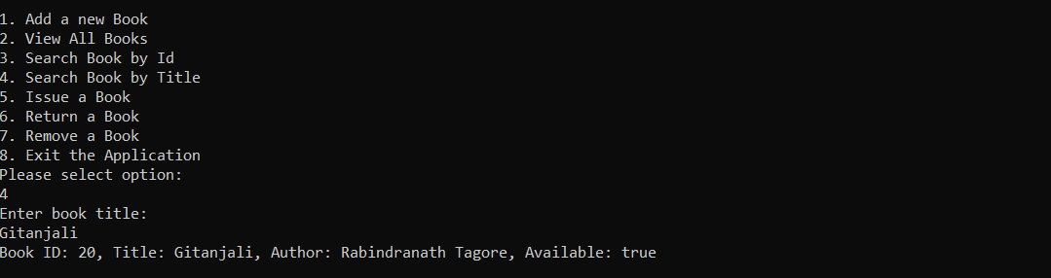
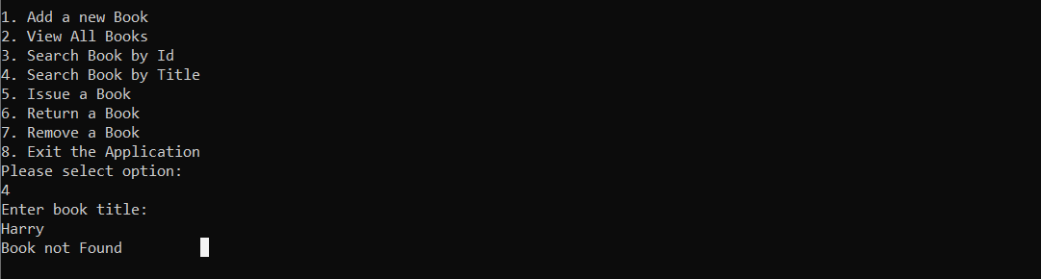
- Issue a Book:
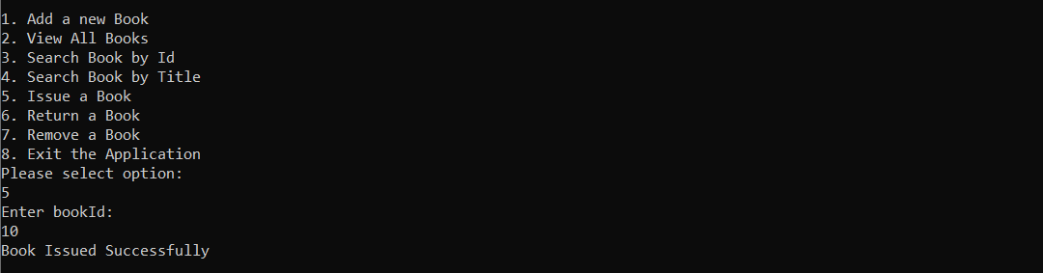
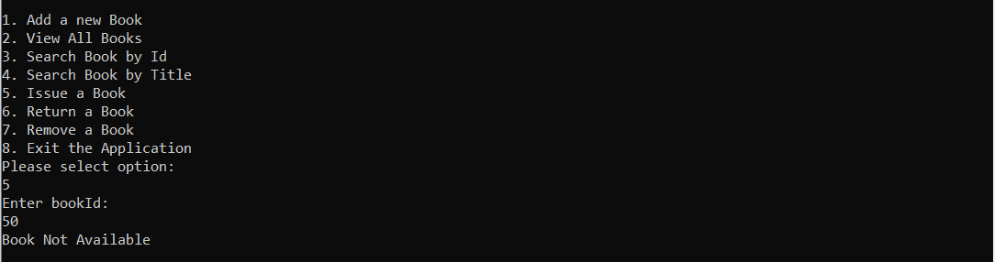
- Return a Book:
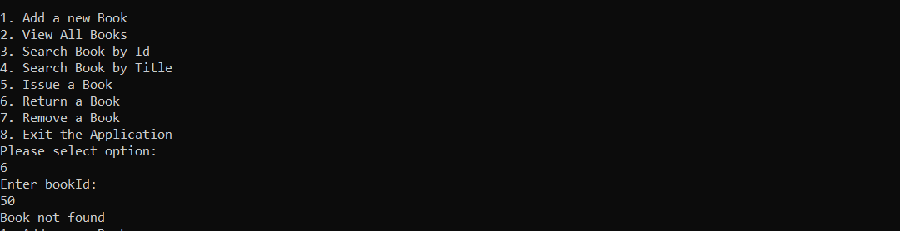
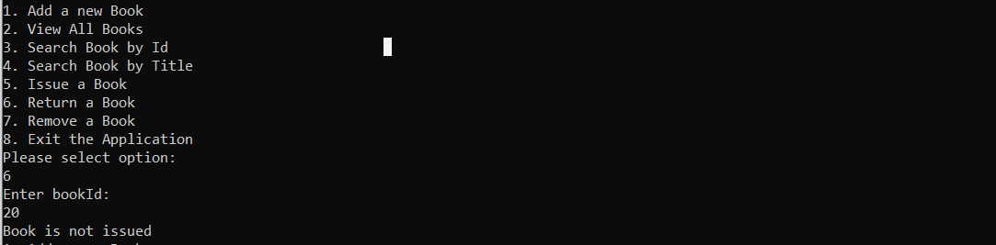
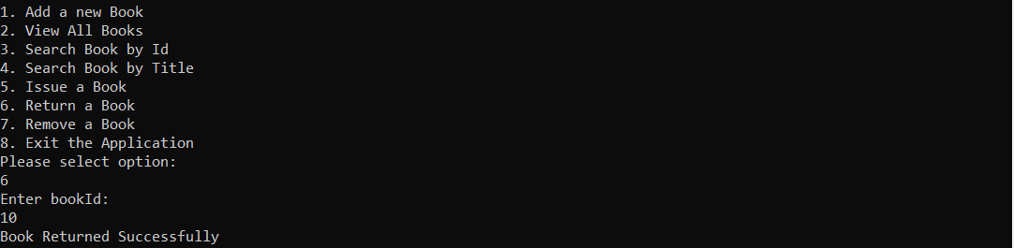
8.Remove a Book:
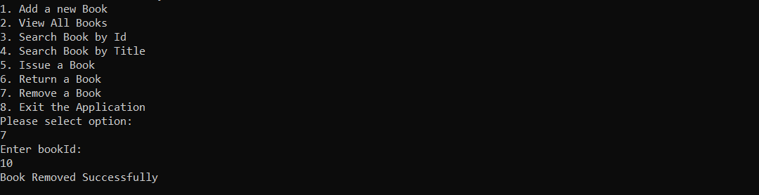
- Exit from application:
